PEERING CONNECTION VPC TO VPC

Step 1: create vpc1
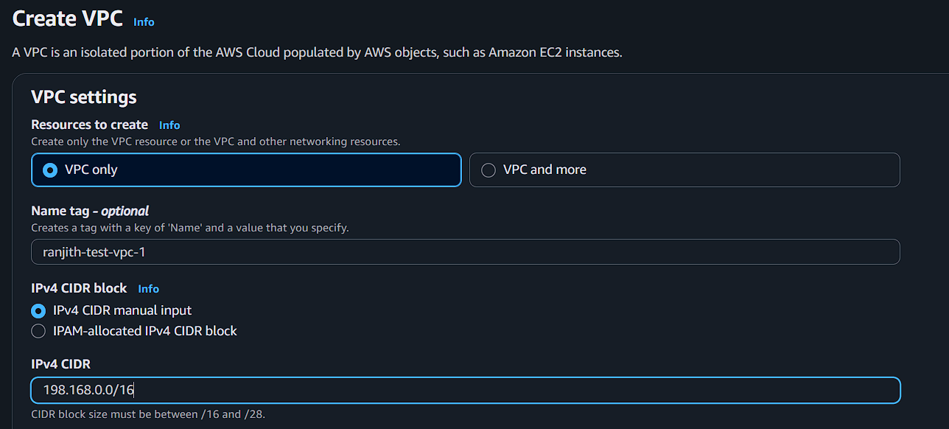

Step 2:create vpc2
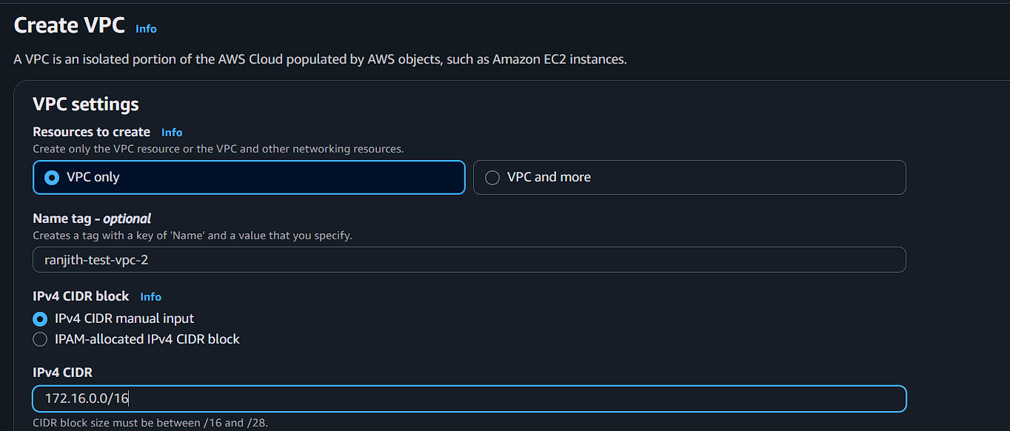

Step 3: create subnets vpc1
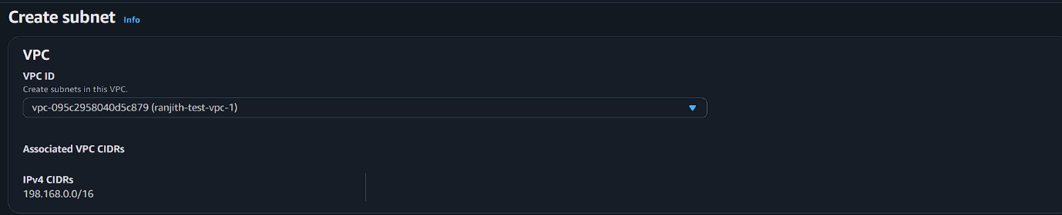
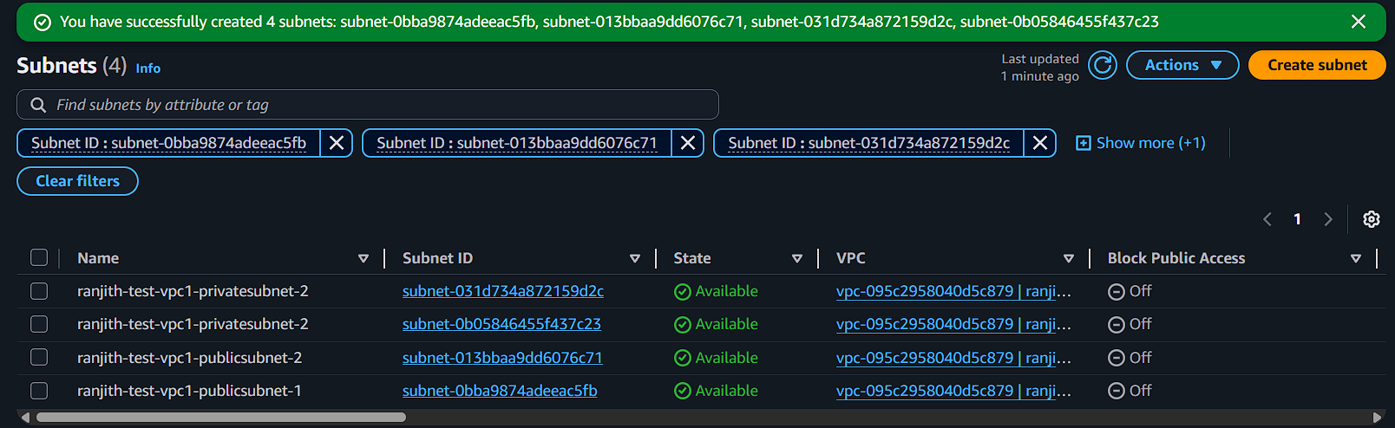

Step 4:create subnets vpc2
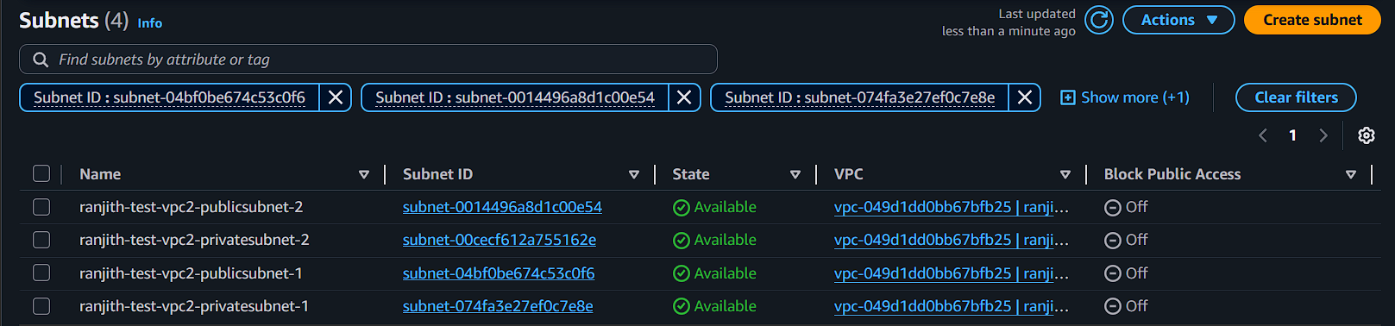
Step 5:create internet gateway vpc1
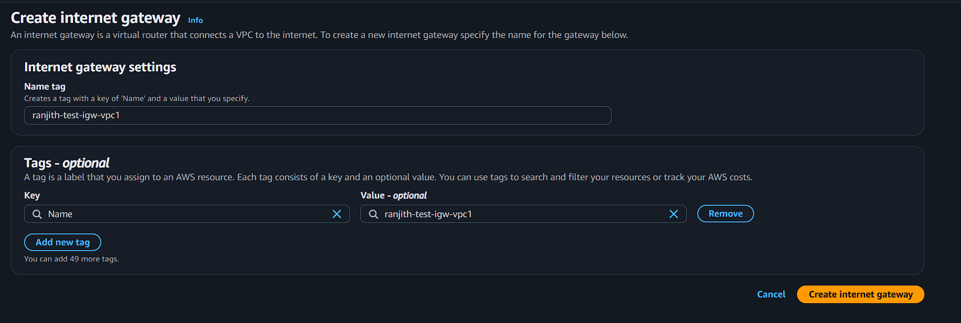

Step 6:create internet gateway vpc2
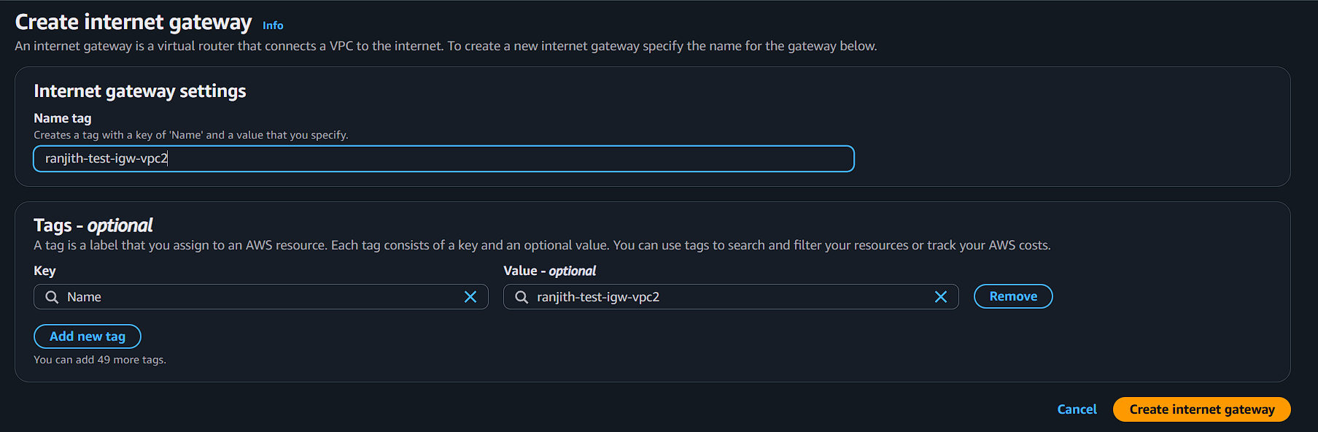

Attach the internet gateways to correct vpc’s
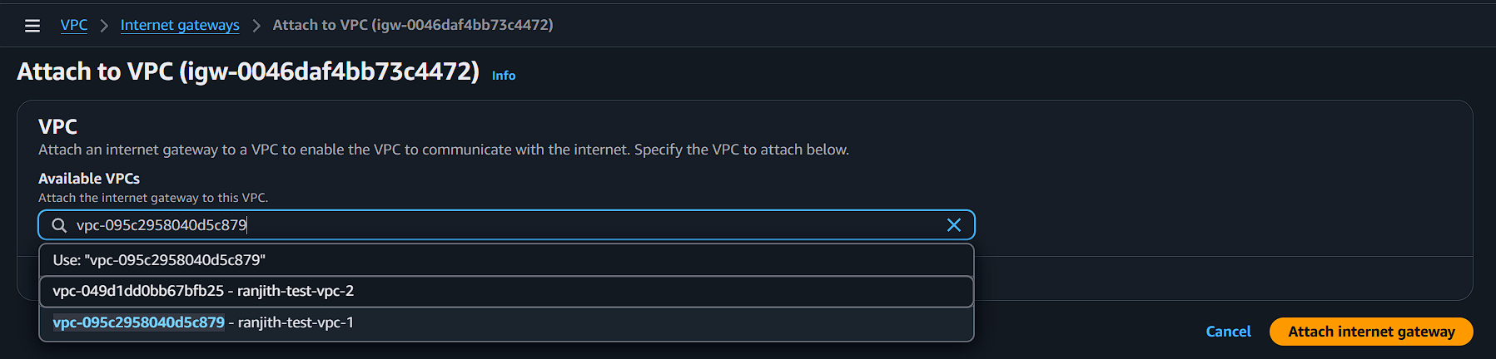
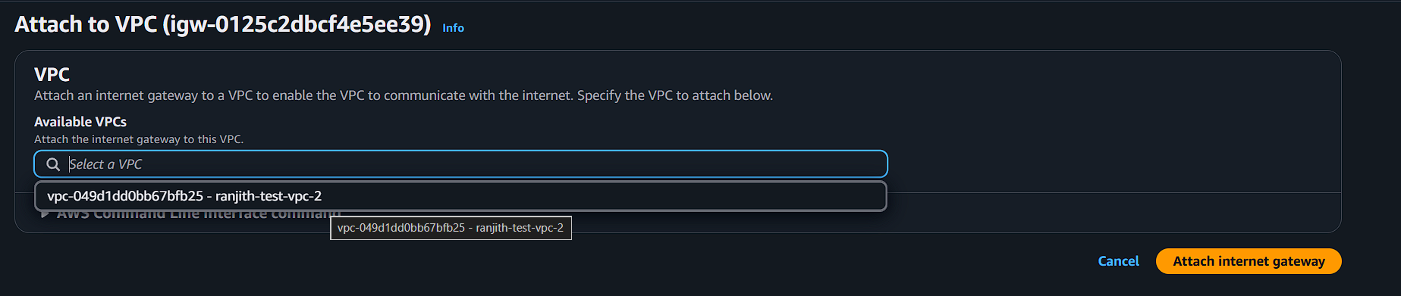
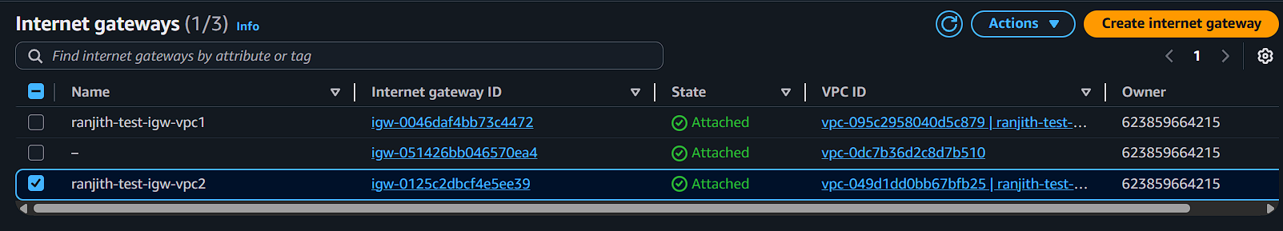

Step 7: create route table vp1 and vpc2
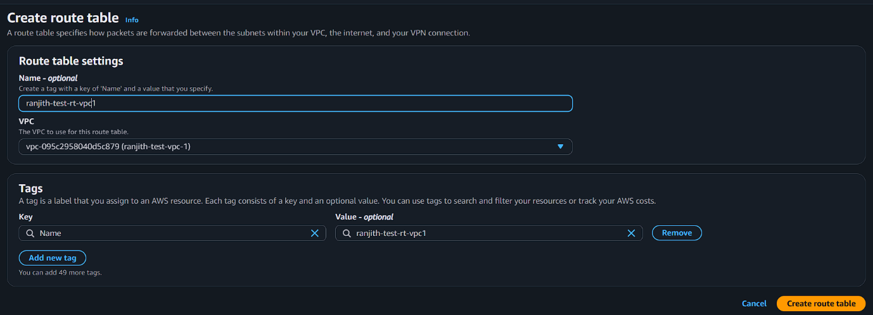
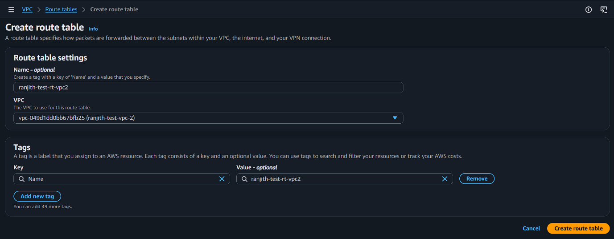

Associate the subnets for the vpc1 and vpc2
Vpc1
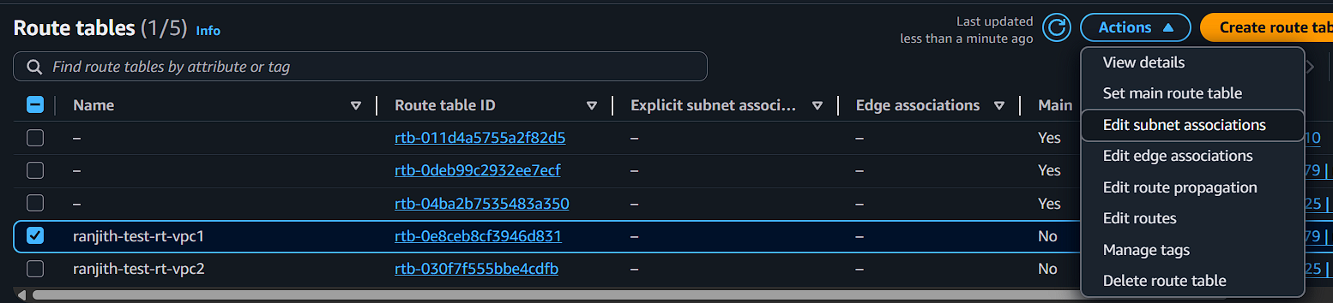
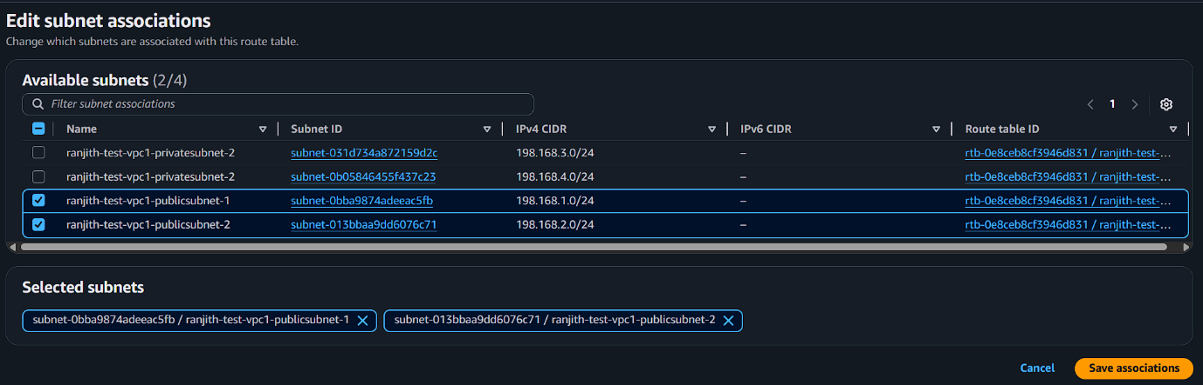
Vpc2
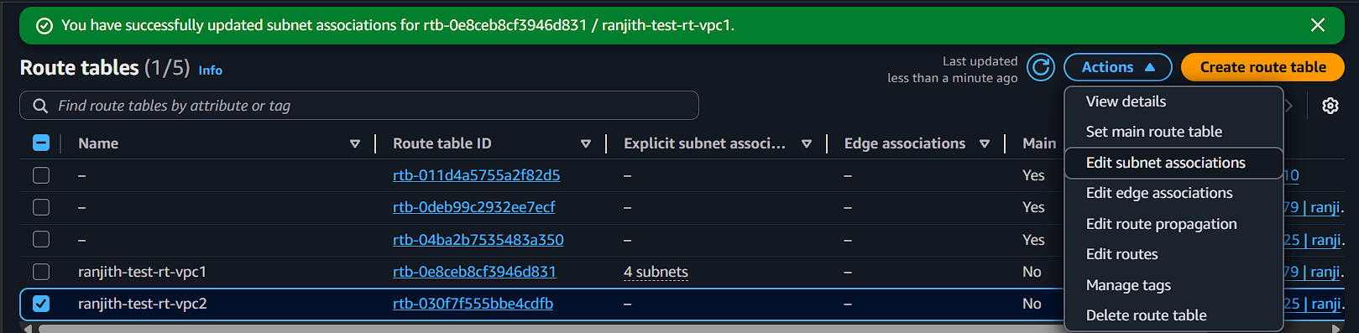
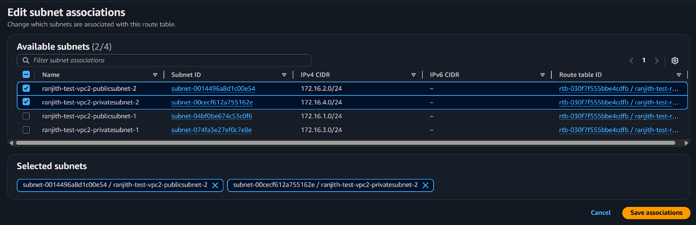

Edit the route tables
Vpc-1
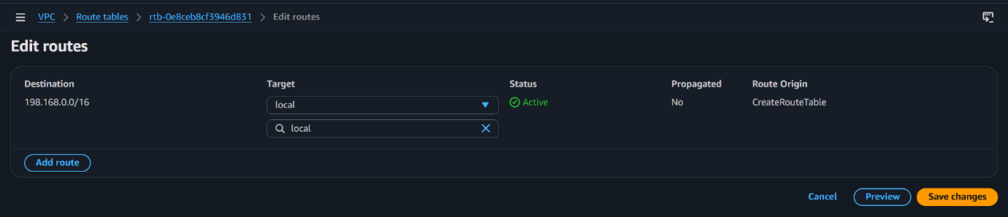
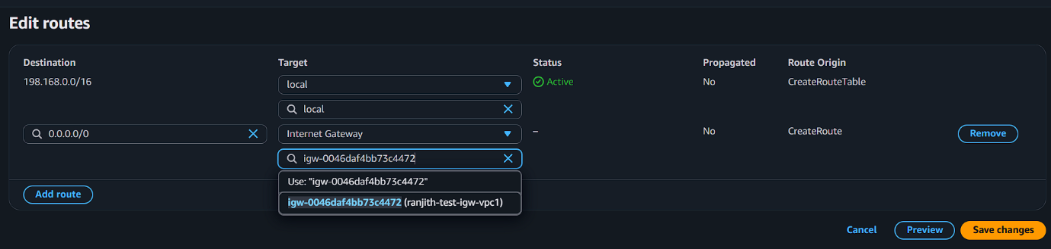

Vpc 2

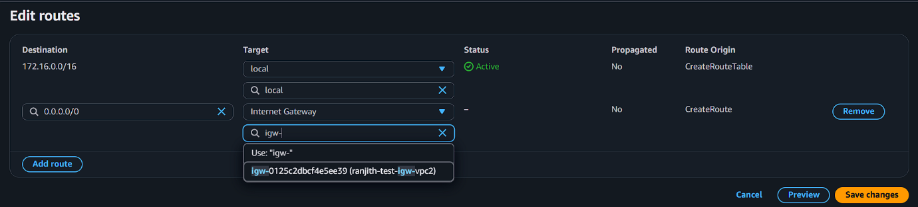

Step 8:create peer connection:
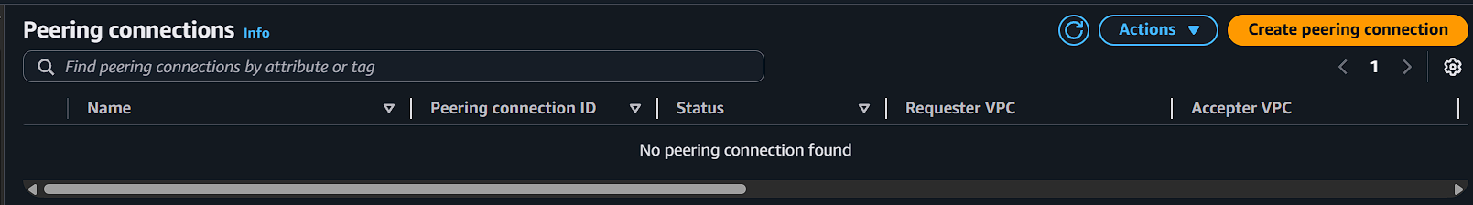
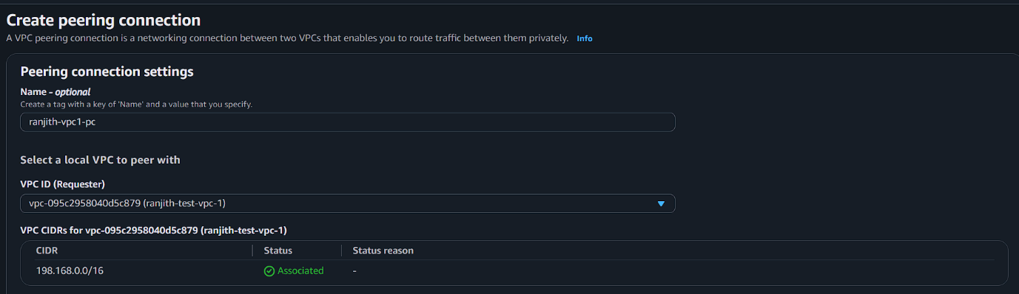
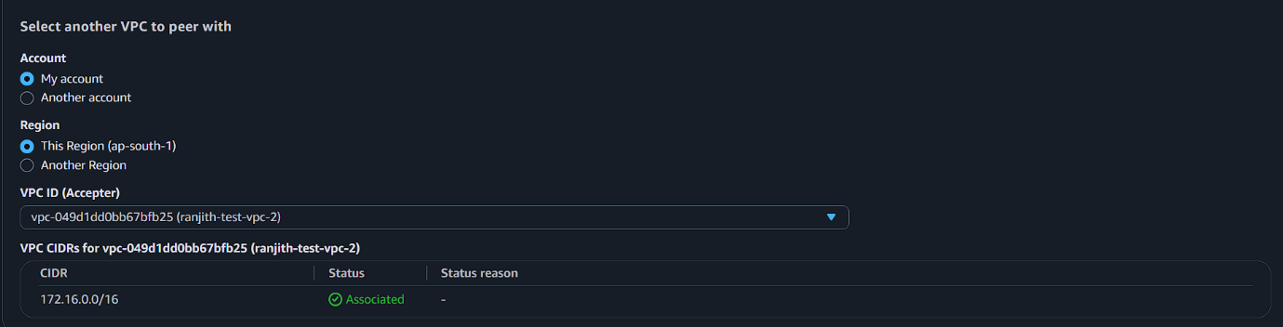
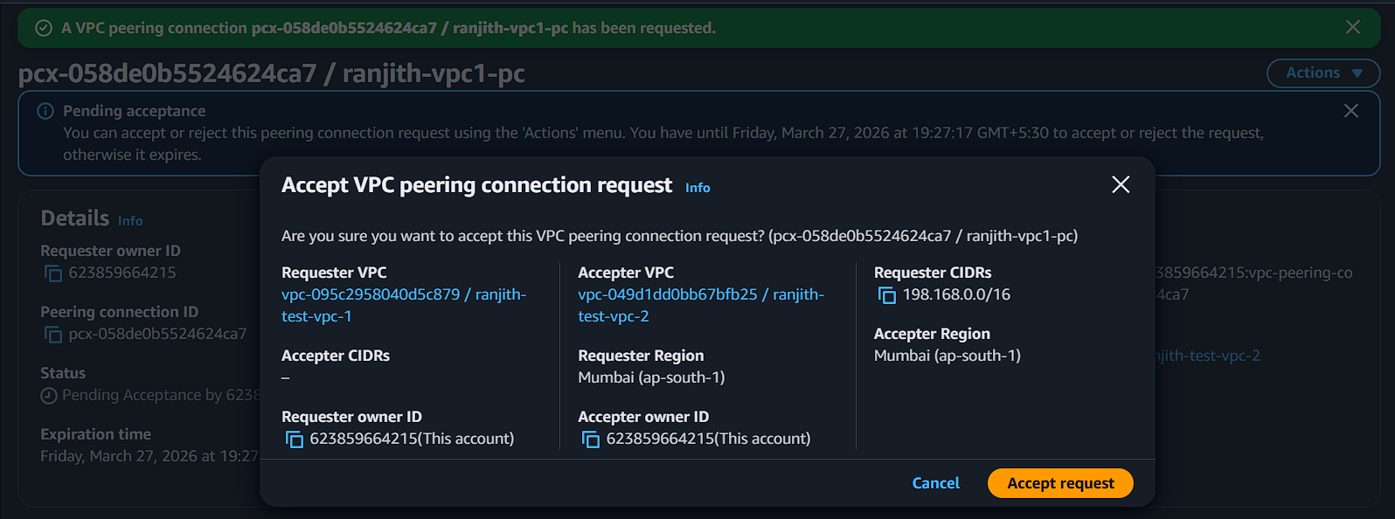

Edit the route table
Vpc1 route edit to put vpc2 cidr range
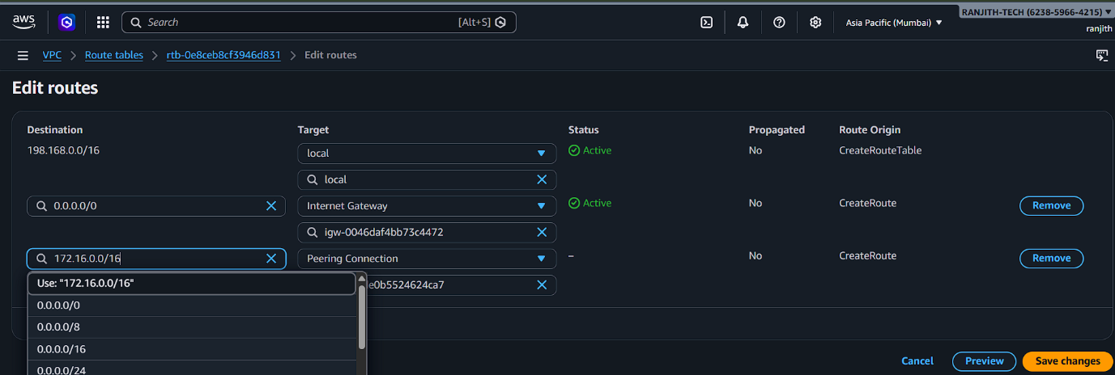

Vpc2 route edit to put vpc1 cidr range
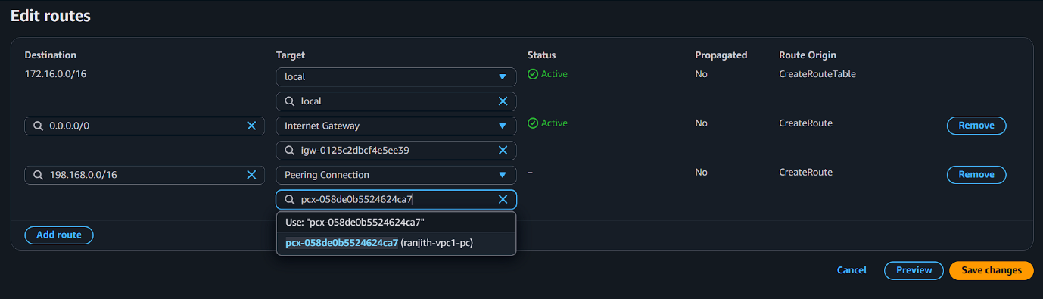

Step 9:launch instance vpc1v-m and vpc2-vm

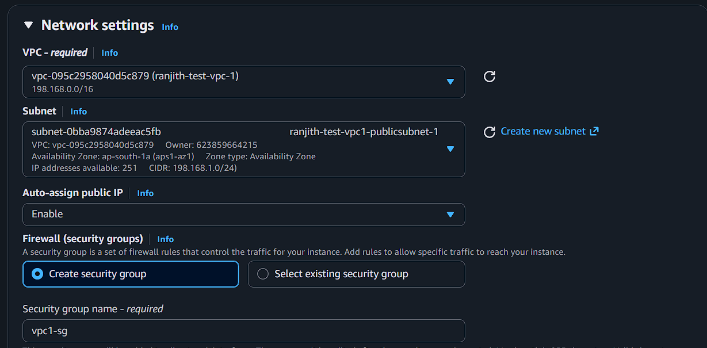
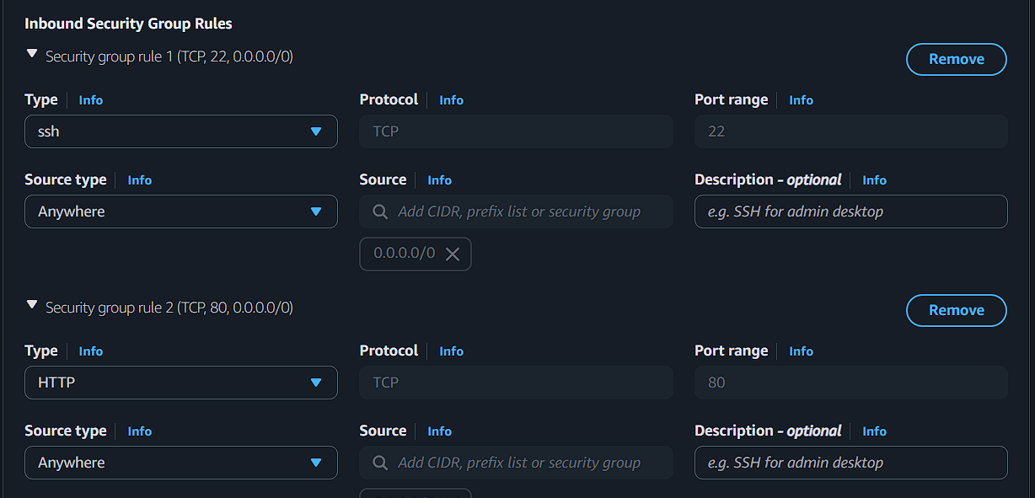

Vpc 2
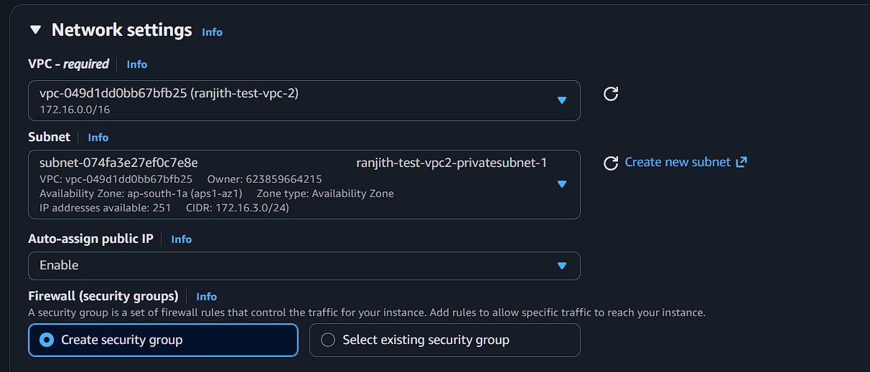
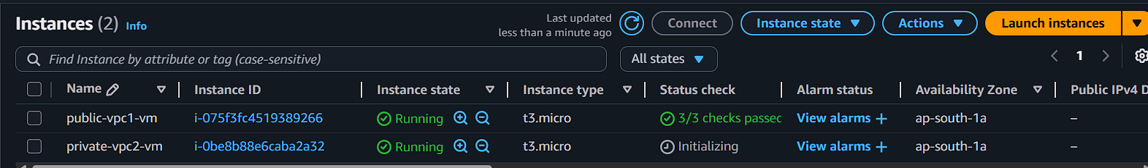

Connect instance ssh
